21 grep -n -E “\[\]$” filename: This command is used to match the any set of characters and \ ignores the special meaning of the character following it .

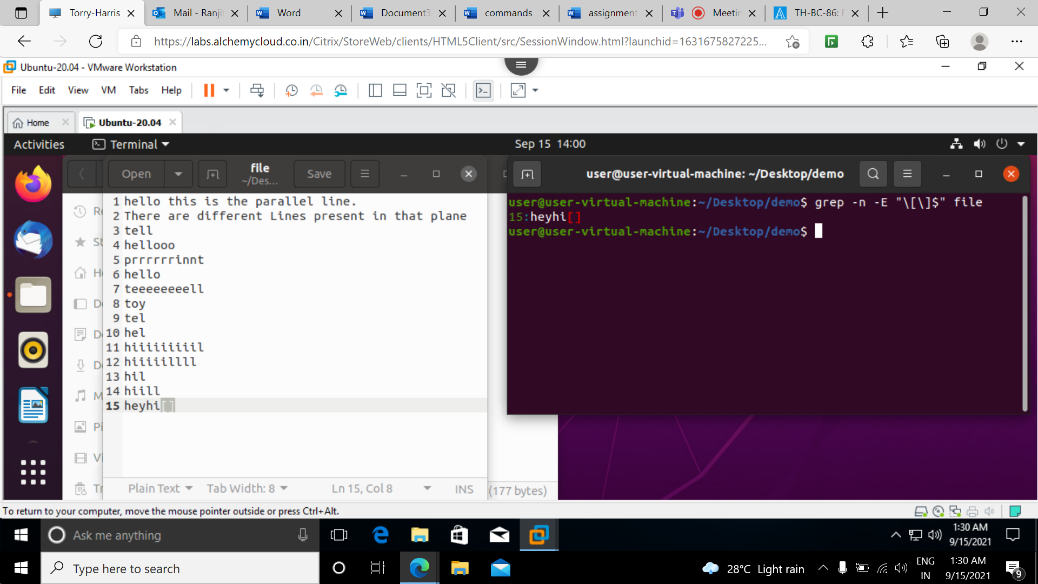

22 grep -n -E “^[A-S].\*” filename:

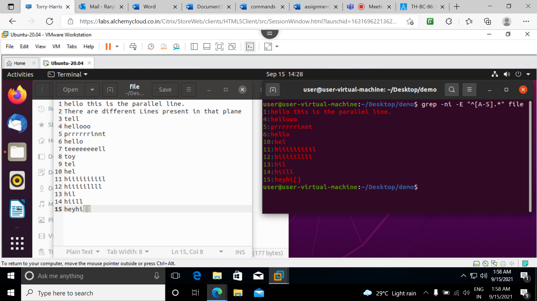

23 grep -ni -E “^h[^i].\*l$” filename: This command will not print the character inside [].

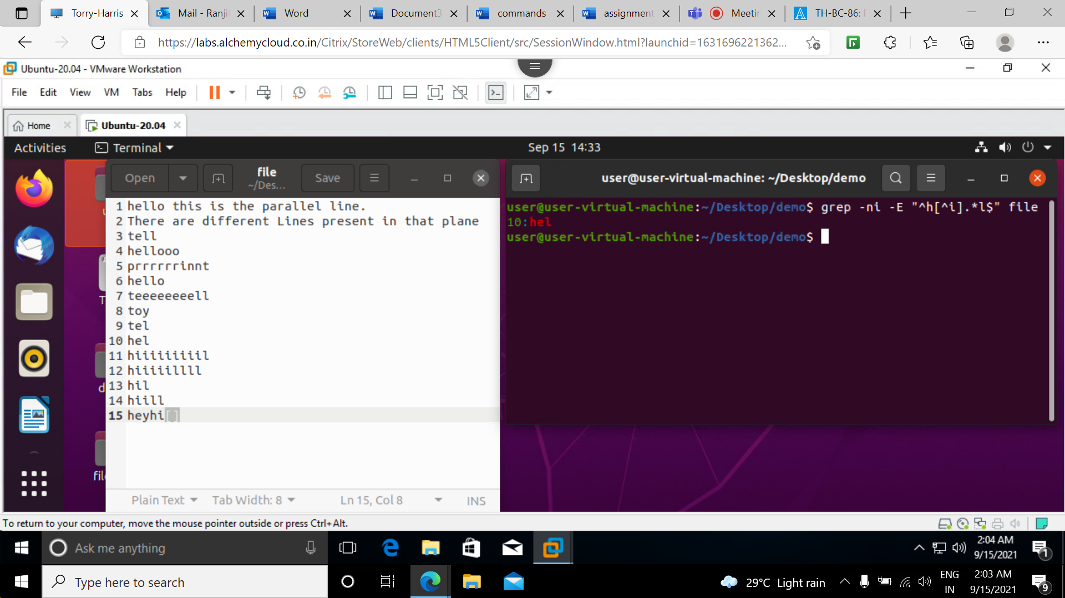

24 grep -c “ “ filename

grep -c -w “ “ filename

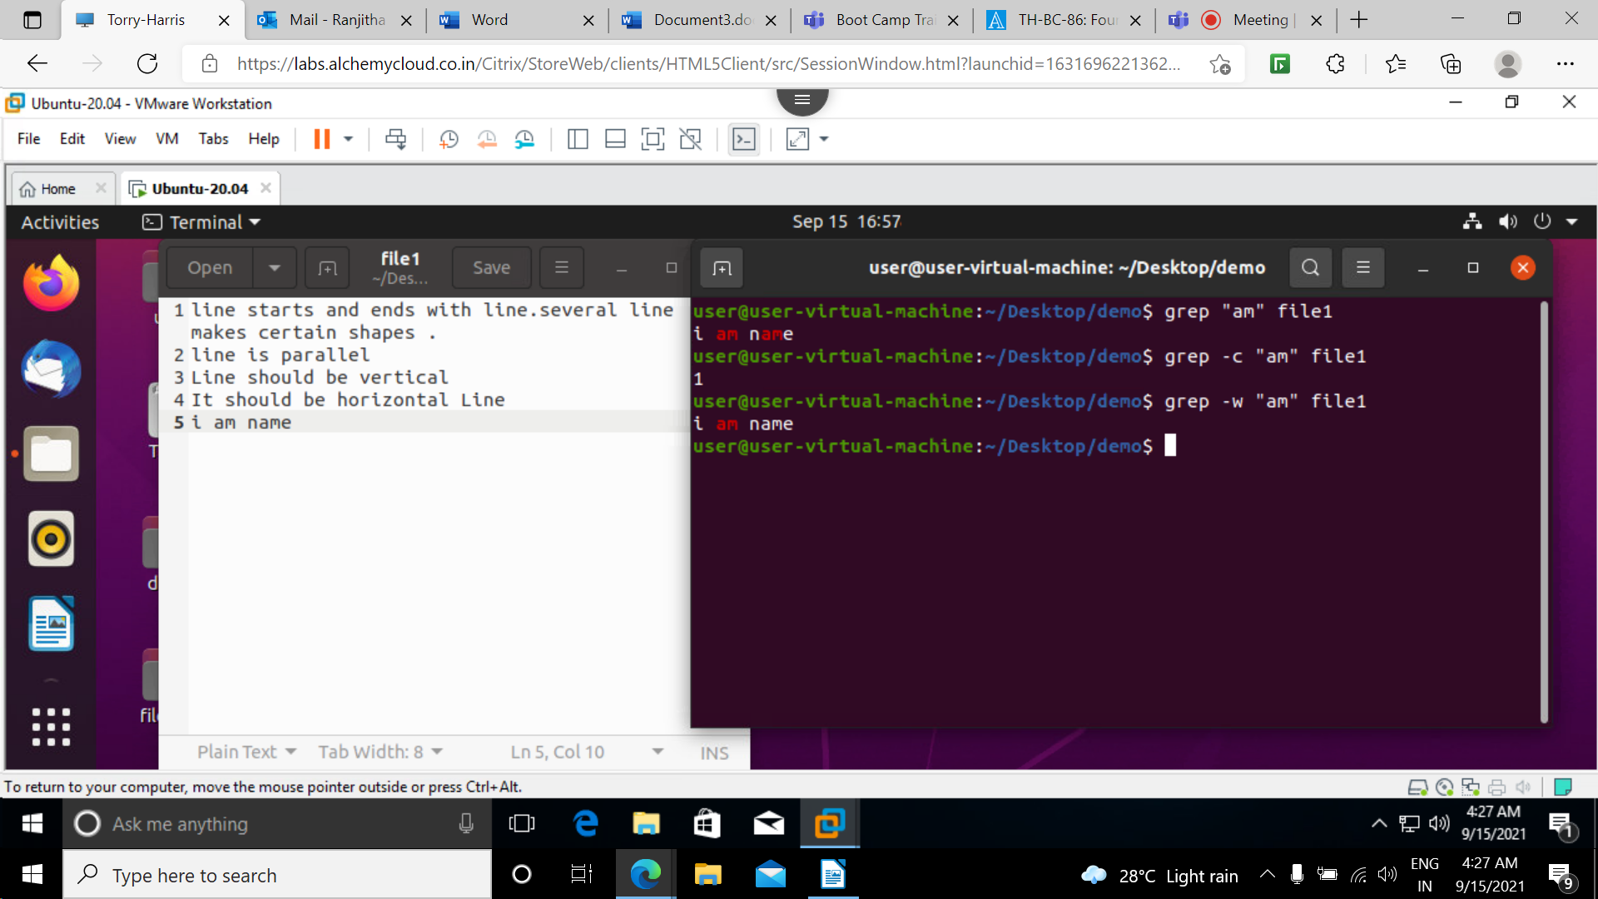

cut command: This command is for cutting out the sections from each lines of files and wrinting the result as output.

-c used to cut by character this can be list of numbers separated comma or range of numbers separated by hyphen.

-b used to extract the specific bytes

-f used to extract thebuseful information we need to cut by fields rather than columns

--compliment used as combination with other options either with –f or -c

--output-delimiter :by default it is same as input delimiter that we specify in the cut with –d option

